

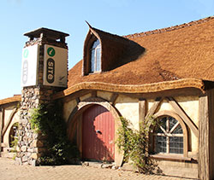



Transportation

Strategic Case

2021/22 – 2023/24

Table of Contents

1. This Business Case 2

1.1 Purpose and Structure 2

1.2 Associated Documents 2

1.3 Matamata Piako District today 4

2. The Transportation Activity 5

2.1 Activity Scope 5

2.2 Partners and Key Stakeholders 5

2.3 The Network 6

2.4 Critical Assets and Lifelines 8

2.5 Management 9

2.6 Procurement and Delivery 9

2.7 Programme and Funding 9

3. National, Regional and Local Context 11

3.1 GPS 11

3.2 Arataki 11

3.3 Road to Zero 11

3.4 Multi Modal Approach 13

3.5 RLTP 13

3.6 Council’s Outcomes and Priorities 14

4. Levels of Service and Performance 16

4.1 LTP measures – 2019/20 16

4.2 ONRC measures 17

4.3 Demand for Services 19

5. Challenges and Options (Problem Statements) 20

5.1 Local Issues 20

5.2 Aligning Objectives 21

5.3 Problems and Benefits 21

6. Data and Evidence 24

Figure 2.1: ONRC (2017) Figure 2.2: Roading Replacement Cost 6

Figure 2.3: Roading Expenditure 9

Figure 2.4: Roading Lifecycle Management Categories 10

Figure 4.1: Bridges not capable of 50 MAX 19

Table 2.1: Matamata Piako DC Asset Valuation Comparison - 1 July 2018 to 1 July 2019 7

Table 2.2: Matamata Piako DC Valuation of Roading Assets - As at 1 July 2019 7

# This Business Case

## Purpose and Structure

This Strategic Case provides the operating context for the Transportation activity. It describes the activity and the alignment with national, regional and local drivers and documentation. This includes the outcomes and levels of service sought, along with the level of service achieved. Problems and benefits are identified for response and development of options and actions through the Programme Business Case.

The approach differs from that used in 2018 to simplify its use. This separates the documents and tailors them more towards the different readers.

Previously a comprehensive Activity Management Plan contained the Strategic Case, Programme Business Case and International Infrastructure Management Manual based AMP, which followed a Council wide format.

**Programme Business Case**

-by Work Category

-Options

**Activity Management Plan**

-Levels of Service

Growth and Demand

Risk Management

**Strategic Case**

## Associated Documents

**Programme Business Case**

The programme Business case sets out the issues and options for each work category, culminating in a preferred programme and investment level.

**Long Term Plan**

The long term plan is Council core strategic planning tool. It is developed to meet Local Government Act 2002 requirements, and alongside the Business Cases prepared for Waka Kotahi (NZTA).

Activity Statement

The activity statement provides a succinct overview of the Transport Activity within the Long Term Plan. This will be the basis of consultation with the community in the first half of 2021. Due to the inconsistency of Local Government Act 2002 and Land Transport Management Act 2003 processes there are some risks around funding and approvals.

The 2018 Activity Statement is available on page 136 of the LTP <https://www.mpdc.govt.nz/pdf/CouncilDocuments/Plans/LongTermPlan/LTCCPS/18-28/LTP-Section6.pdf>

Infrastructure Strategy

Council is advancing its Thirty Year Infrastructure Strategy as part of Long Term Planning process. This includes identifying key issues ahead for the Transport sector. Previous, bypasses for both Matamata and Morrinsville townships were discussed; since 2018 these initiatives have been set aside.

Growth is expected to continue across the Matamata-Piako district, but at a manageable rate. Primary production and processing continue to be key economic activity.

FS and FIS - Affordability

Council has identified affordability as a key issue for the 2021 – 2031 Long Term Plan. The impacts of the COVID-19 Pandemic remain uncertain in terms of MPDC and Waka Kotahi revenue.

Activity Management Plan

Matamata-Piako District’s Transport Activity Management Plan (AMP) gives the overview of our transport network and customer’s requirements for the expected level of service.

The plan adopts a Council-wide format and follows the guidance of the IIMM.

The plan provides direction for the use of Councils funds and how we propose to maintain, operate, renew and improve the Matamata-Piako transport network.

We want to clearly show the value of any investment made in addressing our strategic transport problems and undertaking core business activities. Any investment needs to achieve the desired outcomes and benefits for our customers and represent value for money. It is also important that we show how we will meet regulatory requirements and environmental protection.

**ONRC reports**

The suite of reports developed by the Road Efficiency Group have been a core part of this Business Case. These are discussed in section 4.42.

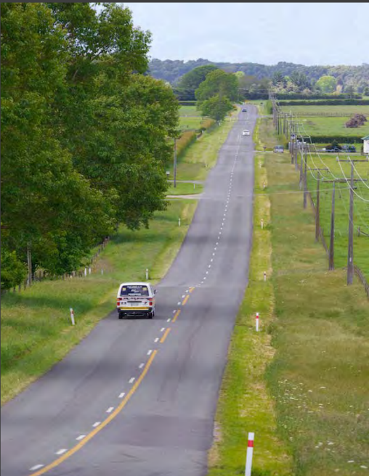

## Matamata-Piako District today

Matamata-Piako District has benefitted from continually increasing tourism and visitor numbers to Hobbiton. The Hauraki Rail Trail and the Te Aroha to Matamata cycle path have and will add to tourism numbers.

There has been a change of land use as the demand for housing in Auckland pushes horticulture, into our district on land previously used for dairy farming.

Dairy farming properties are also recognising opportunities and reducing commercial risk by diversifying e.g. partial conversions into poultry farming. There has been expansion and increased production in processing plants in the dairy, meat and poultry sectors.

Also increased number of subdivisions and residential dwellings. The housing increase in 2019 and 2020 has significantly exceeded the forecasted growth. One of the limiting factors for growth in Morrinsville is the disposal of stormwater.

With the items mentioned above there is a need to understand the effects on traffic movements. This creates the need to collect additional data. With improved technology and collaboration through the Regional Asset Technical Accord (RATA) this technology is now available at a cost effective rate. We have collected high speed pavement data through two surveys now and we recognise the need to continue to collect data to recognise network trends.

Our network is subject to a high percentage of heavy traffic. Recent changes in legislation have allowed for additional legal width and increased tonnage on approved trucks. Our network has to be suitable for these changes. The changes in the use of our transport network increases our requirement for stronger bridges, safer, wider roads and appropriate sight distances.

Of the 380 plus bridges in our district we have 53 bridges that are recognised as critical. That is, they are either main routes for local traffic or alternatives if the State Highway routes are not available. These bridges have priority for staged load assessments.

With the Government Policy Statement focus on healthier modes of transport, the district is pleased to be continuing expansion of its active transport network. This correlates with MPDC’s outlook for the construction of further cycleways/shared paths throughout the district and within our townships.

This is likely to evolve into more shared pathways 2.5m wide. Waka Kotahi (NZTA) is now subsidising footpath maintenance and renewals. As we are now endeavouring to utilise the Waikato Regional Infrastructure Specifications (WRITS) the WRITS needs amendment to adhere to the Governments direction. This will ensure Developers are building and vesting with Council appropriate infrastructure that meets the needs of Community.

Additional Public Transport with a daily bus service operating from Matamata to Hamilton via Waharoa and Morrinsville. Also a new service operating between Morrinsville and Te Aroha. This needs to have appropriate infrastructure, bus stops and parking facilities.

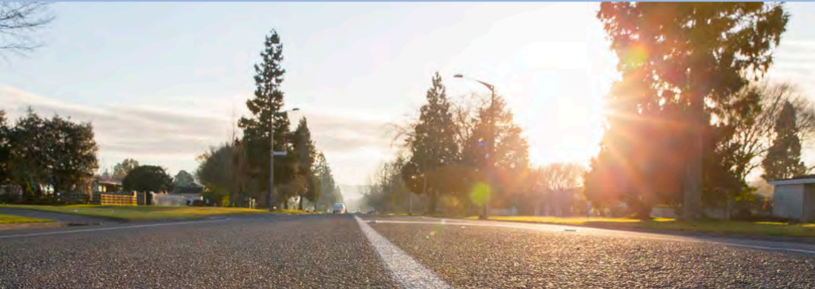

# The Transportation Activity

## Activity Scope

What We Do

We own and maintain 1,005 kilometres of local roads within the district, including 954 kilometres sealed and 51km unsealed roads. These are all the roads in the district except for state highways (which include Broadway and Firth Street in Matamata, Allen Street in Morrinsville and Whitaker/Kenrick Streets in Te Aroha), which are managed by Waka Kotahi (NZTA). The road network also covers the cycleways and footpaths, and includes bridges and structures, street lighting, road signage and markings, and on-street parking within the road corridor.

Why Do We Do These Activities?

Roads provide for a wide variety of users with diverse needs, including private and commercial car drivers and passengers, freight operators, dairy tankers, stock trucks, quarry trucks/machinery, public transport, harvesting contractors/farm machinery, cyclists and pedestrians. They also support and enable economic growth and, when designed appropriately, enhance living environments and amenity. In addition to providing access to properties, the road corridor is also where utilities are usually located (e.g. gas, power, telecommunications, water, sewer and stormwater).

## Partners and Key Stakeholders

The delivery of transport services to the district, visitors and others is a partnership. Matamata-Piako District acknowledges the financial support and guidance of Waka Kotahi (NZTA) as funder and state highway network operator. The partnership with Waka Kotahi (NZTA) is key to focussed programme development and delivery.

The Waikato Region is a leader in terms of joint planning and collaborative working. RATA has proven most valuable for MPDC and there are real benefits that have contributed to this Business Case.

Locally Council has established a formal process of representation for Māori within the district. The forum is a standing committee of Council and the structure was developed through discussions with Māori nominated representatives. The Forum meets quarterly.

The purpose of Te Manawhenua Forum to Matamata-Piako is, “To facilitate tangata whenua contribution to Council’s decision making.” The forum considers matters to sustainably promote the social, economic, environmental and cultural wellbeing of Māori communities for today and for the future.

The Forum includes representatives from Council, Ngāti Hauā, Ngāti Rahiri-Tumutumu, Raukawa, Ngāti Maru, Ngāti Whanaunga, Ngāti Paoa and Ngāti Hinerangi. Ngāti Tamaterā also have the ability to join.

Council partners with the Hauraki Rail Trail Charitable Trust in the development and operation of the rail trail.

## The Network

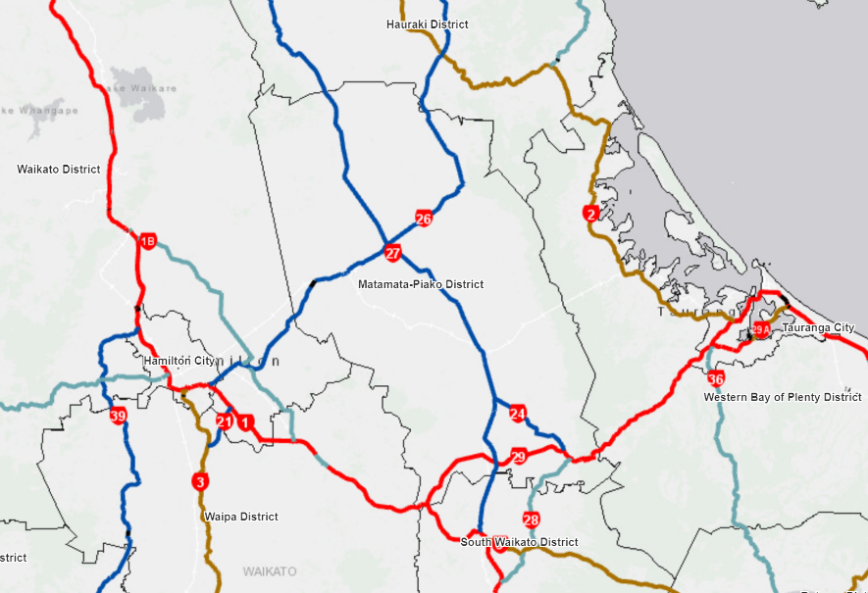The district is intersected with several State Highways and also has a number of high capacity routes.

85% of the network is rural and all but 51km of the network is sealed.

Traffic numbers are high on routes serving primary production and manufacturing, with extensive HPMV/50MAX use.

The total asset value is over $400 million, the majority being associated with the sealed road network

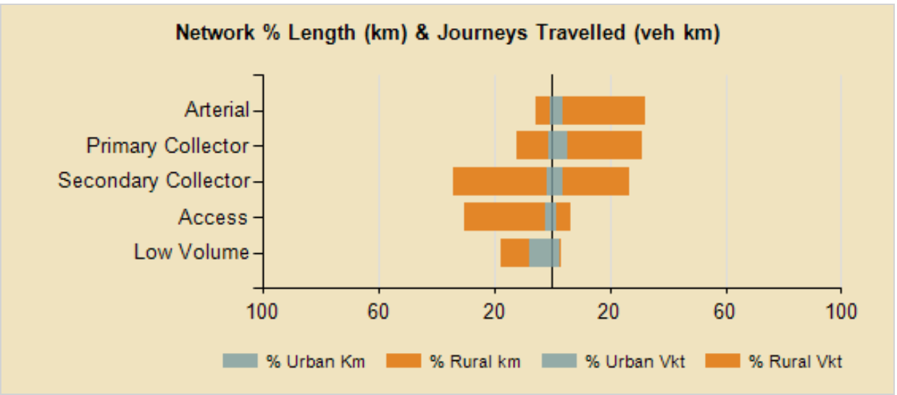

Figure 2.1: ONRC (2017) Figure 2.2: Roading Replacement Cost

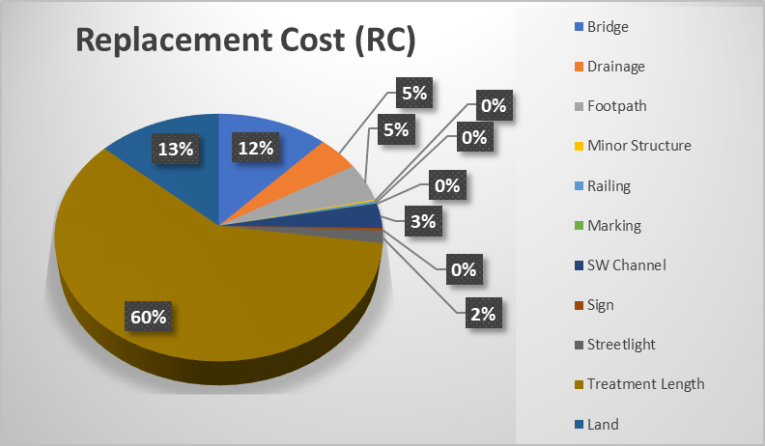

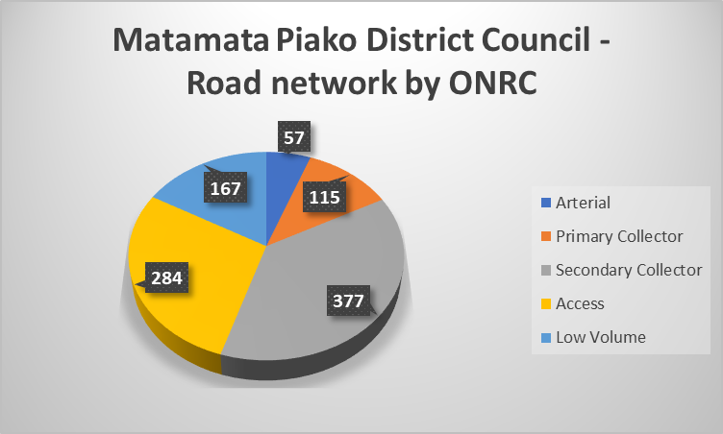

The change since the previous valuation is indicated below.

Table 2.1: Matamata-Piako DC Asset Valuation Comparison - 1 July 2018 to 1 July 2019

|  |  |  |  |
| --- | --- | --- | --- |
|  | ORC | ODRC | AD |
| 30-Jun-19 | $425,037,802 | $309,174,645 | $5,636,476 |
| 30-Jun-18 | $388,329,292 | $284,705,912 | $5,839,840 |
| Difference | $36,708,510 | $24,468,733 | -$203,364 |
| % Change | 9% | 9% | -3% |

The components that comprise the transport system are tabulated below.

Table 2.2: Matamata-Piako DC Valuation of Roading Assets - As at 1 July 2019

| **Grouping** | **Component** | **Lenth(m)** | **Quantity (No.)** |
| --- | --- | --- | --- |
| Pavement Surface | AC | 10,497 | 116 |
| Concrete | 51 | 2 |
| Grade Chips | 90,4762 | 1,537 |
| Unsealed Surface | 8,462 | 9 |
| Bridges and Large Culverts | Steel Beams and Timber Deck | 70 | 6 |
| Concrete Beams and Concrete Block | 2,168 | 105 |
| Steel Beams and Concrete Deck | 254 | 12 |
| Steel Beams and Concrete Deck K2K | 26 | 3 |
| Concrete Beams and Concrete Deck K2K | 17 | 1 |
| Drainage | Culverts / Sumps |  | 7,791 |
| Drainage_side entry sump |  | 68 |
| Bridge Culvert and Stock Underpass |  | 187 |
| Footpath | All | 311,202 | 1,995 |
| Railings | All | 10,546 | 886 |
| Minor Structure | MS_Fence | 740 | 3 |
| MS_Overbridge | 9 | 1 |
| MS_Rwall | 655 | 47 |
| MS_Weigh Station | 37 | 1 |
| Signs | All |  | 6,725 |
| Street Lighting | Light |  | 2,769 |
| Bracket |  | 2,677 |
| Pole |  | 1,815 |
| Surface Water Channels | Dished Channel | 3101 | 61 |
| Kerb and Channel | 226,935 | 1,631 |
| Unknown | 29,787 | 81 |

## Critical Assets and Lifelines

The network provides a range of routes between locations, and supplements the State Highway as key connections. As such there is a fair degree of redundancy. Analysis of routes has identified where there are key issues and critical infrastructure. Two examples include bridges crossing the Waihou River that are not affected by flood, and State Highway alternatives near Te Poi.

Council acknowledges that the public’s risk tolerance lies where there is a considerable loss of service in terms of road access. In general this is for roads rated as Secondary Collector or above in the One Network Road Classification – the route will be available in moderate weather events and an alternative route will be available. Clearance of incidents affecting road users and road user information will have a high priority.

Critical assets are considered those assets in which failure would result in a major disruption to the supply of services. These assets are regularly monitored for their condition to ensure their replacements are planned and completed to minimise the risk of failure. Our critical assets include all treatment plants for water and wastewater, pump stations, trunk mains and associated structures. Regional Arterial roads are the most critical roads for the wider community.

An assessment has also been made for all bridges in our district and the following table identifies the critical ones as they have the highest vulnerability and impact rating, offering no alternative route.

|  |  |
| --- | --- |
| **BRIDGE** | **ROAD NAME** |
| 7, 8 | Pioneer Road |
| 15, 16, 18, 19 | Tahuna-Ohinewai Road |
| 31, 32, 33, 34, 35, 36, 223, 231 | Paeroa-Tahuna Road |
| 39, 252 | No. 1 Road |
| 42, 43, 44, 45, 46, 47 | Morrinsville-Tahuna Road |
| 54 | Tauhei Road |
| 57, 253 | Piako Road |
| 68 | Ngutumanga Road |
| 70 | Stanley Road North |
| 73, 74 | Te Aroha-Gordon Road |
| 92 | Mace Road |
| 99, 100 | Stanley Road South |
| 109 | Shaftesbury Road |
| 138 | Avenue Road |
| 142, 143, 144, 145, 174 | Morrinsville-Walton Road |
| 175, 176 | Walton Road |
| 183, 184 | Wardville Road |
| 194 | Okauia Springs Road |
| 212 | Old Te Aroha Road |
| 103, 104, 229 | Alexandra Road |
| 233 | Whitaker Street |
| 234 | Church Street |
| 235 | Gilchrist Street |
| 240 | Te Poi South Road |
| 247 | Studholme Street |
| 130, 131, 132 | Kereone Road |

## Management

Works are managed by Council’s in-house professional services unit. This unit is now incorporated within Council, rather than the former consultancy model. Asset management and strategic planning for the activity is undertaken through the Policy and Strategy Section.

MPDC benefits from the Waikato RATA in terms of procuring professional services and assistance with data management and improvement.

## Procurement and Delivery

Council adopted its Procurement Strategy in March 2018, and scored at 45 in the REG Procurement Self-assessment (interpreted as “our organisation gets by but has opportunities for improvement.”)

In the Procurement Strategy, Council’s transportation objectives in procurement are identified as being:

* To share risk and encourage innovation.
* To assess with an evidence based business case approach.
* To create a road system that provides for the safe, efficient and strategic movement of traffic (vehicular and pedestrian) in a manner that promotes the sustainable management of resources used.
* (To) engage with New Zealand businesses in a productive way and help those businesses to become more competitive internationally
* (To) build greater public trust that expenditure is well planned and well executed

Council is a member of the Waikato Local Authority Shared Services Limited (WLASS).

WLASS is a CCO solely owned by the 12 Waikato local authorities including Waikato Regional Council. The company was established in 2005 to promote shared services between local authorities across the Waikato region. By encouraging and enabling the councils to work together, WLASS helps councils to reduce costs, achieves effectiveness and efficiency gains, reduces duplication of effort, eliminates waste through repetition, promotes and contributes to the development of best practice, and helps to improve customers’ experiences. The Waikato RATA is managed under the LASS portfolio.

The majority of physical works are delivered through the “Road Maintenance Contract” which was awarded to Fulton Hogan commencing 1 July 2019, for three years with two additional periods of two years rollover (+2+2).

## Programme and Funding

MPDC’s work programme is developed for a ten year period (for the Long Term Plan} with an indication of key decisions and projects out to thirty years (for the Infrastructure Strategy). Details and forecasts are prepared for the immediate three years covering the National Land Transport Programme and the first period of the LTP.

The overall spend on the transportation activity is $15 million per year, and is comprised of maintenance, renewals and improvements as indicated.

Figure 2.3: Roading Expenditure

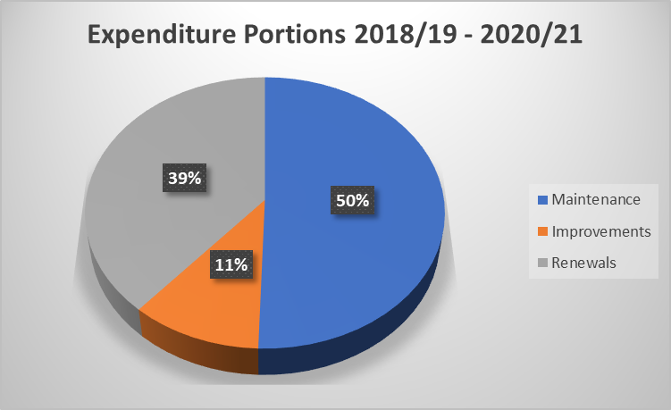

The expenditure is broken down further as illustrated. Much of the new works – Council funded is discussed in the Low Cost Low Risk category.

Figure 2.4: Roading Lifecycle Management Categories



# National, Regional and Local Context

## GPS

The Land Transport Management Act (LTMA 2003) requires the Minister of Transport to issue the Government Policy Statement on Land Transport (GPS) every three years. The GPS sets out the government’s priorities for expenditure from the National Land Transport Fund over a 10-year period, and how funding should be allocated. Regional land transport plans must be consistent with the GPS, and Waka Kotahi (NZTA) must give effect to it with regards to land transport planning and funding.

The draft GPS 2021 outlines four strategic priorities for land transport:

* Safety,
* Better Transport Options,
* Improving Freight Connections
* and Climate Change.

## Arataki

Arataki is the long term vision for Waka Kotahi and includes national objectives through to regional initiatives.

While recognising the GPS principles, the immediate focus is safety, to support implementation of the Road to Zero Safety Strategy for New Zealand and associated Action Plan (2020-22), and regional safety strategies. The items with a particular emphasis relevant to Matamata-Piako District Council are:

* continuation of safety treatments targeting high-risk intersections, and run-off road and head-on crashes on high-risk rural roads (rural roads are roads with speed limits >80km/h)
* separated facilities and infrastructure improvements in areas with significant levels of walking and cycling

## Road to Zero

In late 2019 The Ministry of Transport released the Road to Zero Road Safety Strategy. This was in response to the lack of achievement in reducing deaths and serious injuries.

A target of a 40 percent reduction in deaths and serious injuries by 2030 is proposed.

Underpinning this vision are seven proposed guiding principles:

01 We plan for people’s mistakes

02 We design for human vulnerability

03 We strengthen all parts of the road transport system

04 We have a shared responsibility for improving road safety

05 Our actions are grounded in evidence and evaluated

06 Our road safety actions support health, wellbeing and liveable places

07 We make safety a critical decision-making priority

Five key action areas are identified and those actions where Council plays a significant role are identified in bold text:

**01 Improve the safety of our cities and regions through infrastructure improvements and speed management**

02 Significantly improve the safety performance of the vehicle fleet

03 Treat road safety as a critical health and safety at work issue

**04 Encourage safer choices and safer behaviour on roads**

**05 Drive action through effective system management**

In line with these action areas, the ‘immediate’ area where Council plays a role are identified in terms of infrastructure, Roads Safety Co-ordination (RSC) or community advocate.

|  |  |  |
| --- | --- | --- |
| 01 | Invest in safety treatments and infrastructure improvements | (Infrastructure) |
| 02 | Introduce a new approach to tackling unsafe speeds | (Infrastructure + RSC) |
| 03 | Review infrastructure standards and guidelines | (Infrastructure) |
| 04 | Enhance safety and accessibility of footpaths, bike lanes and cycleways | (Infrastructure) |
| 06 | Promote the availability of vehicle safety information | (RSC) |
| 08 | Support best practice for work-related travel | (RSC) |
| 10 | Prioritise road policing | (advocate) |
| 12 | Support motorcycle safety | (RSC) |
| 14 | Strengthen system leadership, support and coordination | (Infrastructure + RSC) |

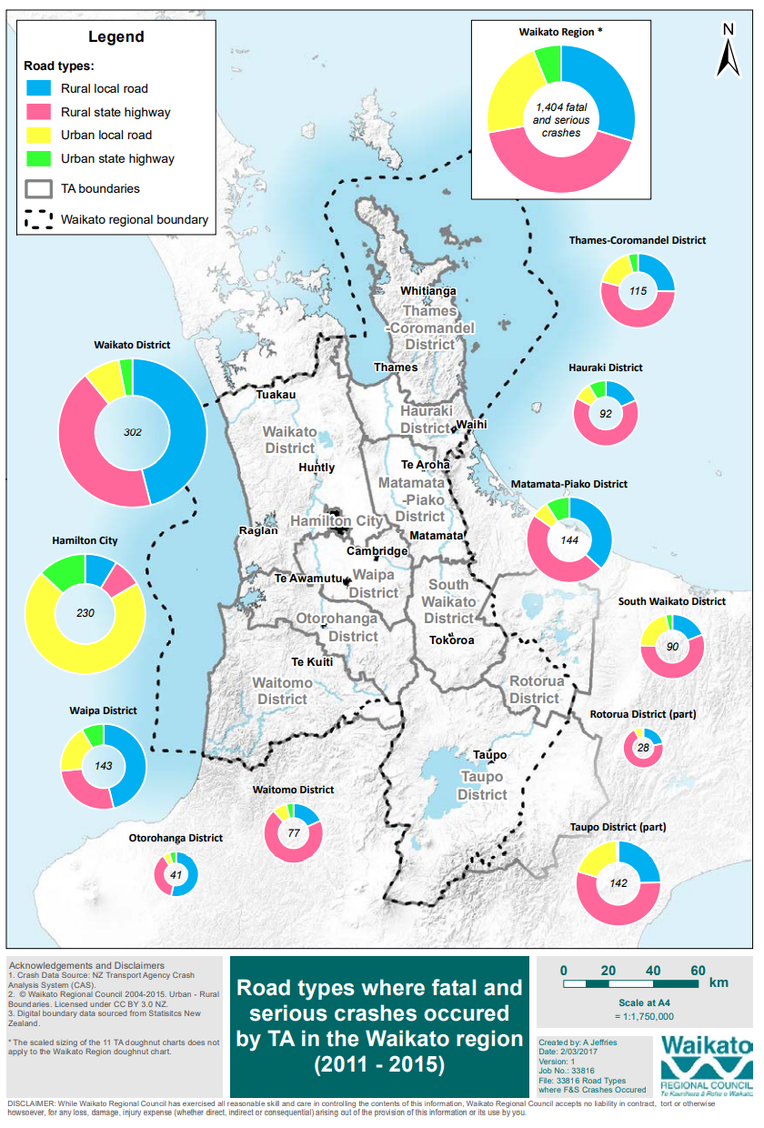

Road safety is a national, regional and local issue. The record across the Waikato is poor, and crashes on rural roads in Matamata-Piako district are a significant problem.

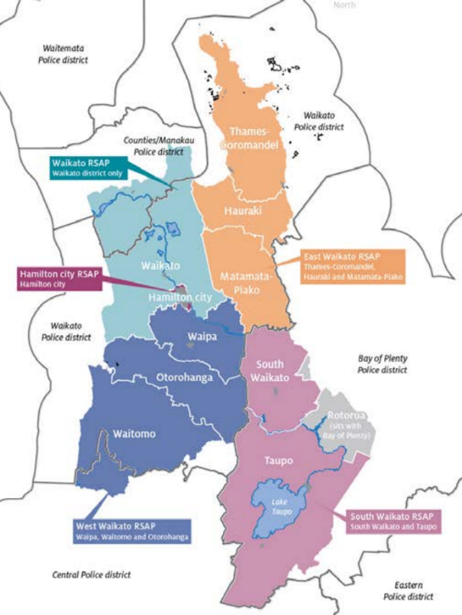Matamata-Piako is part of the East Waikato Road Safety Cluster and undertaken Road Safety promotion programmes jointly.

## Multi Modal Approach

With the GPS focus on healthier modes of transport. This ties in nicely with MPDC’s outlook for the construction of further cycleways/shared paths throughout the district.

This is likely to evolve into more shared pathways 2.5m wide. Waka Kotahi (NZTA) is now subsidising footpath maintenance and renewals. As we are now endeavouring to utilise the Waikato Local Authority Shared Services “Regional Infrastructure Technical Specifications” (RITS) the RITS needs amendment to adhere to the Governments direction. This will ensure Developers are building what the Community and Government are requesting. It also provides consistency with our neighbouring RCA’s.

Additional Public Transport with a daily bus service operating from Matamata to Hamilton via Waharoa and Morrinsville. Also a new service operating between Morrinsville and Te Aroha. This needs to have appropriate infrastructure, bus stops and parking facilities.

## RLTP

Matamata-Piako is a member of the Waikato Regional Transport Committee and Regional Advisory Group who are responsible for the development of the Waikato Regional Land Transport Plan.

**Draft 2021 Waikato Regional Land Transport Plan**

Vision *‘An integrated, safe and resilient transport system that delivers on the well-beings of our diverse Waikato communities.’*

Strategic Objectives

| **Objective** | **Objective Statement** | **Targets** | **Weighting** |
| --- | --- | --- | --- |
| Strategic Corridors and Economic Development | An efficient and resilient land transport system that advances regional economic wellbeing and facilitates the movement of people and freight on strategic corridors in the upper North Island | Target relating to travel time reliability OR completion of a key project e g. Expressway extension  [% of journeys on key freight and tourist routes that meet a predictability target, being the average journey time + 5% from the last financial year.] | 40% |
| Road Safety | A safe transport system in the Waikato region where no-one is killed or seriously injured | Links to Road Safety Strategy consultation  Target relating to DSIs or social costs | 35% |
| Access and mobility | A transport system that provides an inclusive range of integrated, safe, quality travel choices for people to meet their social, economic and cultural needs | Target relating to PT boardings OR mode share | 25% |
| Climate Change |  | Based on reduction of carbon emissions |  |

## Council’s Outcomes and Priorities

We have a vision for our community to make Matamata-Piako ‘the place of choice.’ Our vision for the infrastructure services is to continue to provide services to our current and future community in an affordable way that represents good value for money. The Infrastructure Strategy provides a strategic roadmap for the next 30 years and beyond. It provides the direction and guidance on what decisions needs to be made, and when, in order to get to where we want to be in 2051.

The following graphs illustrates the role of transport in Council’s strategic vision.

***Matamata-Piako – The Place of Choice***

***Lifestyle. Opportunities. Home.***

|  |  |  |
| --- | --- | --- |
| **Connected Infrastructure** |  | **Economic Opportunities** |
| Infrastructure and services are fit for purpose and affordable, now and in the future. | We are a business friendly Council. |
| Quality infrastructure is provided to support community wellbeing. | Our future planning enables sustainable growth in our district |
| We have positive partnerships with external providers of infrastructure to our communities. |  |

**Our Most Likely Scenario – Roading and Footpaths**

The Roading network connects people with their needs, enables businesses to access resources/ markets and provides people with social, cultural, recreational and employment opportunities.

Council approved new residential zoning in the District Plan in 2017. The Infrastructure Strategy includes funding to provide roading and footpaths to service these new areas. The increase in freight transport on our roads also means that we have included funding to review the structural integrity of some of our bridges, which will also improve the resilience of our network.

In terms of the Transport Activities there are priorities associated with these challenges, these have been considered in the development of our problem statements (section 5)

|  |  |
| --- | --- |
| **CHALLENGES** | **STRATEGIC PRIORITY** |
| Resilience | Providing a reliable Transport Network |
| Demand Management | Providing people with alternative transport options  Manage higher performance expectations |
| Growth and Productivity | Support economic growth and productivity |
| Road Safety | Reduce the fatal and serious injury crashes on our transport network |

**Strategic Drivers, Challenges and Responses**

As a community we face a range of external factors that can influence our decision making. As part of our long term plan we have identified four drivers that have an impact across all of our activities.

| **DRIVER** | **MOST LIKELY SCENARIO FOR OUR DISTRICT** | **IMPACT ON INFRASTRUCTURE** | **OUR RESPONSE** |
| --- | --- | --- | --- |
| **COMPLIANCE** | Increased level of central and regional government direction particularly regarding public health and environmental outcomes. | This will impact on how we manage our infrastructure to ensure we protect and support public health and environmental outcomes. It is expected that this will require increased investment.  While the cost of future changes to regulations and legislation is unknown, we have included $27 million in our budgets over 30 years to implement recommendations and requirements resulting from this across all our assets. | * We will comply with national standards. * We will use technology. |
| **GROWTH AND DEMAND** | We are forecasting that our population will increase over time, with the majority of this increase happening among the older age groups (60+) and urban areas.  We are also experiencing continued growth in tourism to our district. | Population growth and land intensification increases demand for infrastructure services in urban centres.  Ageing population increases demand for accessibility and changes the way in which infrastructure assets and services are used.  Continued growth in the tourism sector increases demand for visitor facilities and increased levels of service of existing facilities.  We have included projects to a total value of $19 million to provide for growth in  our district. | * We will plan for sustainable growth and manage demand. * We will provide additional capital and operational expenditure over the next 30 years. |
| **RESILIENCE** | The global climate change we are currently experiencing means that  we have more frequent severe weather events like storms and droughts. | More frequent severe weather events and droughts put pressure on our infrastructure, and may require improved capacity and capability to cope with severe weather events and natural hazards, and assist with the community recovery following such events.  No allowance has been made for the replacement of damaged infrastructure but rather to ensure we fund the replacement of our assets as it is needed.  We have included budgets of around $14 million per annum for the renewal of our assets.  By completing the renewal programme and providing additional infrastructure we are improving the resilience of our current network. assets and services. | * Our infrastructure will   support or improve public health benefits.   * Our infrastructure will support or improve environmental outcomes. * We will maintain our current assets to maintain levels   of service.   * We will provide for the replacement of critical assets at the end of their useful life. |
| **AFFORDABILITY** | The median household income for our district is $55,320 (2016), with around 68.5% of our population holding a formal qualification (2013 census).  With the increase in the aging population, we are also forecasting that the average household size will decrease from 2.49 to 2.29 by 2048, with a higher proportion of single income or fixed income households. | The ageing population and moderate growth places a cap on the ability of our community to pay for infrastructure assets and services | * We will optimise our investment and apply asset management practices to our planning. * We will smooth our costs where possible over time. * Non-critical assets will be run to failure and only replaced   if there is still a demand and requirement for the asset. |

# Levels of Service and Performance

## LTP measures – 2019/20

The following table illustrates the achievement levels for the performance measures in the Long Term Plan. Many of these are the Mandatory Performance Measures.

|  |  |  |  |  |
| --- | --- | --- | --- | --- |
| **LEVELS OF SERVICE** | **PERFORMANCE MEASURE** | **What we target** | **Target Achieved?** | **2017/18**  **2018/19**  **2019/20** |
| We will provide a roading network that is safe for all users. | The change from the previous financial year in the number of fatalities and serious injury crashes on the local road network expressed as a number. | A reduction in the number of fatal and serious crashes from the previous year. | Decrease of fatal or serious crashes from the previous year  **17/18 -** <5  **18/19 -** <3  **19/20 -** <15 | Checkmark  Checkmark  Checkmark |
| We will provide a roading network that is maintained and developed to provide smoothness and comfort. | The average quality of ride on our sealed local road network, measured by smooth travel exposure. | 97% or more | **17/18 -** 99.3%  **18/19 –** not measured  **19/20 -** 93.34% | Checkmark  Close |
| The percentage of the sealed local road network that is resurfaced. | 8.5% or more | **17/18** – 9.95%  **18/19** – 7.94%  **19/20** -6.6% | Checkmark  Close  Close |
| The percentage of footpaths within our district that fall within the level of service or service standard for the condition of footpaths that is set out in our relevant documents | 95% or more within the acceptable level of service | **17/18** - Survey not  completed  **18/19 -** 99.4%  **19/20 -** Not measured | Checkmark |
| We will provide a reliable roading network and will respond to customer service requests in a timely manner. | The percentage of customer service requests relating to roads and footpaths that the territorial authority responds within the time frame specified in the Long Term Plan. | 90% of urgent requests responded to within one working day | **17/18** – 100%  **18/19** –100%  **19/20** - 100% | Checkmark  Checkmark  Checkmark |
| 90% of non-urgent requests responded to within five working days | **17/18** – 97.84%  **18/19** –95.4%  **19/20** -83.2% | Checkmark  Checkmark  Close |

## ONRC measures

Results from the ONRC measures are compiled as follows.

|  |  |  |
| --- | --- | --- |
| **ONRC MEASURES –** | | |
| SAFETY – costumer outcome performance measures | | |
| CO1: the number of fatal and serious injuries | *Increase in crashes on arterial roads, improvement on all other road classifications* | |
| CO2: collective risk (rate per kilometre) |  | *Collective risk is similar to others on lower classification roads, but varies otherwise* |
| CO3: personal risk (rate by traffic volume) |  | Personal risk is generally similar to others but |
| RESILIENCE – Customer Outcome Performance Measures | | |
| CO1: journeys impacted by unplanned events |  | No Data currently (TBA) |
| CO2: instances where road access is lost |  | No Data currently (TBA) |
| AMENITY– Customer Outcome Performance Measures | | |
| CO1: Smooth Travel Exposure (road roughness) |  | |
| *Roads are smoother than others across all categories except Low Volume Access. The percentage is progressively decreasing across all classifications* | | |
| CO2: peak roughness (how bad are the rough bits?) | *Peak roughness increases in line with ONRC, this figure is decreasing across all classifications except Low Volume Access* | |
| ACCESSIBILITY – customer outcome performance measures | | |
| CO1: road not available to Class 1 heavy vehicles or 50MAX vehicles | ? | No Data currently (TBA) |
| COST EFFICIENCY PERFORMANCE MEASURES: | | |
| CE2: chipseal resurfacing (Length & Area) | *The extent of sealing has reduced over time, this reflects a focussed approach and modelling a long term strategy through dTIMS. This also brings the amount of sealing undertaken in line with others. Council is cautious about peat and wetland sites as drainage and waterproofing is vital to pavement preservation.* | |
| CE3: asphalt resurfacing (Length & Area) | *The amount of asphalt resurfacing is minimal so trend analysis is not appropriate.* | |
| CE4: unsealed road metalling |  | No Data currently (TBA) |
| CE10: Maintenance Costs |  | |

## Demand for Services

The demand across the network continues to grow, and there is a high proportion of heavy traffic on high classification routes. Some roads carry over 20% heavy vehicles, and there over 53 km of full HPMV approved roads on the MPDC network.

The development of the Waikato Expressway is/will have some impact on traffic movements within the district. There was an expectation that the SH1 expressway would take pressure off SH’s 24 and 27 which run through the district but traffic numbers have remained relatively high because of the amount of freight and produce transported locally.

There is continual support for walking and cycling and support for cycling was highlighted with ‘shovel reading’ funding being allocated to district projects. The parks and open space activity is focussing on improvement linkages for walking and cycling which will be supported by transportation.

Public transport is available for district residents to travel to Hamilton for work, medical and other commitments. This has proved successful and is a worthwhile mode shift initiative.

The main limitation on heavy traffic mobility is the bridges that cannot accommodate 50MAX (and therefore HPMV) vehicles. The following map shows bridges that restrict 50MAX movement, four of these are located on arterial classified roads.

Figure 4.1: Bridges not capable of 50 MAX

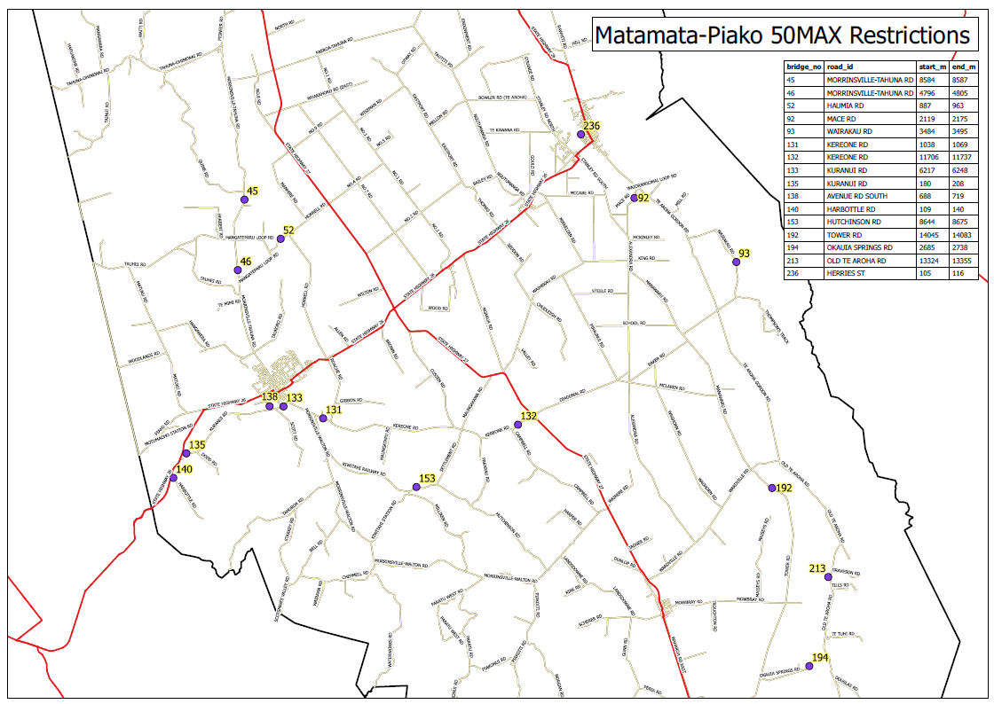

# Challenges and Options (Problem Statements)

## Local Issues

Having considered the national and regional drivers of change, along with the outcomes sought by Council, and Council’s priorities, it is important to remember the local issues. These issues affect road users and are highlighted to keep their experience in mind.

The issues facing the MPDC Transport Activity are summarised spatially in the figure below.

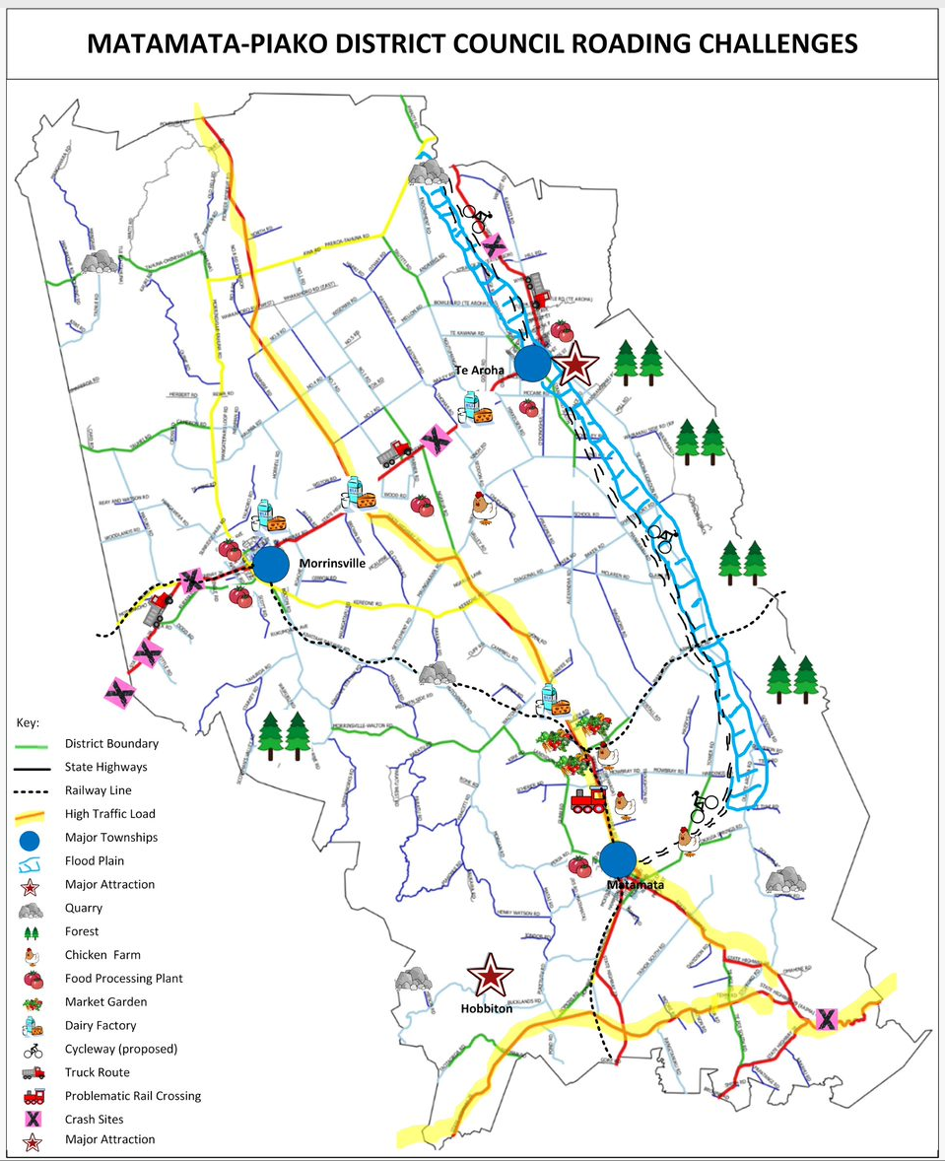

## Aligning Objectives

Matamata-Piako recognises its role in contributing towards the achievement of national and regional priorities, as well as supporting local communities and visitors. Combining these factors is part of establishing relevant problem and benefit statements.

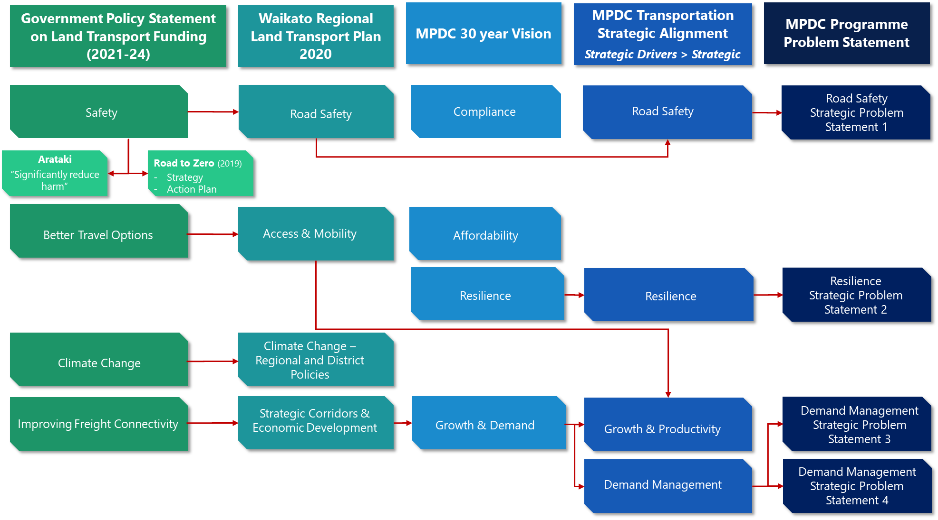

## Problems and Benefits

In 2020 MPDC staff considered the problems, benefits and associated actions for the transportation activity. This review has been used to refine the direction of Council’s 30 year Infrastructure Strategy, and the Programme Business Case.

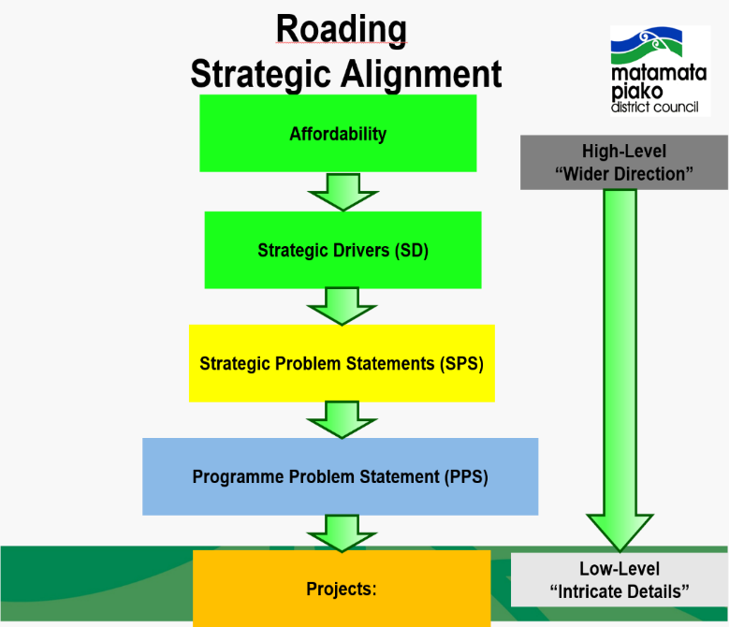The progression of thinking is illustrated in this flowchart

| **Strategic Problem Statement** | **Benefit** | **Programme Problem Statements** | **Example Projects** |
| --- | --- | --- | --- |
| **Road Safety:**  Driver behaviour and infrastructure deficiencies on our road network lead to fatal and serious injuries | Deaths and serious injuries are reduced; improving the outcomes locally and supporting wider initiatives | One lane bridges may be economical but cause road safety issues when being used by a larger volume of users (i.e. tourism) | * Old Te Aroha One Lane Bridge Review * Old Te Aroha One Lane Bridge Update |
| Investment is required to implement safety initiatives | * Safe Network Review * Road Upgrades as per Road to Zero identification on high risk roads * Installation of Signages and road markings * School Safety * Changing Speed limits |
| **Resilience:**  Targeted investment is required to maintain current levels of service in the longer term for our district | The network remains fit for purpose and investment is focused where it is most needed | We have aging assets that need to be maintained, renewed or upgraded | * Bridge Maintenance and Renewals Program * Roading Maintenance and Renewals Program |
| Data collection, quality and gathering is lacking in some areas and are essential variables for future investments | * Process or Systems Review * Process or Systems Update |
| The changing national strategy may affect how we prioritise our programmes and projects | * Government Policy Statement Review   + Change of mode   + Road Safety Action Plan   + Climate change * Routes that support Economic Activity |
| **Demand Management:**  Transportation will need to adapt to the new changes or trends on transport modes and meet higher expectations of our road network performance | The network is fit for purpose meeting the needs of a wide range of users | The number of High Productivity Motor Vehicles (HPMVs) on our road networks lead to faster wear and more road maintenance | * HPMV Road Impact Review * Roading Improvement Projects |
| Alternative modes of transport have been promoted and are being utilised by many | * Provision of E-Vehicle Charging Stations * Construction of Cycleways * Provision of Shared Footpaths * Pedestrian Connectivity Improvement Projects in Towns |
| People who have relocated from urban areas (especially metropolitan areas) and have experienced high levels of service expect the same level of service as new residents of the district and this also negatively affects our customer satisfaction survey | * Information Drive Project * Roading Asset Upgrade Projects |
| **Growth:**  Growth on the network affects its suitability, while affecting the maintenance and management of our road assets | The network remains fit for purpose and investment is focused where it is most needed | New residential areas need to be serviced as outlined in the district plan | * Hinuera to Station Road Link * Station Road, Haig and Jellicoe upgrade works * Hangawera Road to Snell link * Hinuera to Peria Road Link |
| Waharoa is known to be a high potential growth area in the future | * Roading Projects |
| Our road network may limit transportation needs associated industries such as Dairy and Forestry | * Roading Improvement Projects leading to Forest Areas * Roading Improvement Projects   + 50Max Bridge upgrades |
| Long term forecasts on tourism reported higher user volumes in the Matamata area | * Wairere Falls Roading Improvement Projects * Hobbiton Roading Improvement Projects |

# Data and Evidence

MPDC has made data improvement a priority, and with the involvement of the Waikato Regional Asset Technical Accord (RATA), excellent results have been achieved.

The data is regarded as reliable and robust enough to support options analysis and work programmes.

Key data inputs that have been developed and considered in developing the Programme Business Case are:

* Asset inventory
* Asset condition data, including visual rating and network HSD
* Works to date and work expenditure
* dTIMS modelling for pavement surface and structure deterioration and programme
* Bridge inspections