
Pride of Place – Community-led Initiatives Grant Policy 2024 (amended 2025)
Ngā Wāhanga: | Department  Policy, Partnerships and Governance
Te Tūmomo Kaupapahere:  Mō Āwaho | Policy Type:  External Policy
Te Rā o te Whakataunga e te Kaunihera: | Council Resolution Date: 24 January 2024

Ko te pūtake o tēnei kaupapahere I Policy Purpose

This Policy sets out the criteria and allocation process for the Pride of Place - Community-Led Initiatives Grant which supports community to deliver their own small-scale initiatives that contribute to a district that’s better to live, work, play and learn in.
Kaupapahere I Policy
The Pride of Place – Community-Led Initiatives grant is available to not-for-profit groups, organisations and individuals that would like to deliver small-scale events, programmes, temporary installations or activities that benefit the wider wellbeing of those in the Matamata-Piako district and increase its vibrancy.

Council’s Pride of Place project works with communities to create goals for Matamata-Piako district towns and supports community-led initiatives that achieve those goals. Where possible, eligible grant proposals should demonstrate alignment to the Pride of Place goals or present a case for initiatives that will results in general positive social good in the district.
When evaluating a grant proposal, the following criteria will also be considered:

- Locality: The initiative must be located within the Matamata-Piako District.
- Scale: The initiative should be small-scale, and ideally planned and delivered within 1–3 months.
- Community Involvement: The proposal should demonstrate collaboration, partnership, and support from other local funding sources.
- Inclusivity: The initiative must be open to the public and not limited to private or closed events.
- Innovation: The initiative should be new or unique to the area. Repeat funding for the same initiative will generally not be granted.
- Positive Impact: The application should clearly outline the anticipated benefits to the community.
- Viability: The initiative must have a realistic scope, budget, and delivery plan.

Ngā Hua I Outcomes

Organisations and individuals receiving grants are expected to demonstrate how their small-scale initiative achieves the Pride of Place goals and/or benefits the wider wellbeing of those in the Matamata-Piako District.

Ngā kaupapa ka tautokona ā-pūtea I What we fund
The Pride of Place – Community-Led Initiatives Grant will consider funding all costs not listed on the ‘What we don’t fund’ list that follows next.

Ngā kaupapa kāore e tautokona ā-pūtea I What we don't fund
- Initiatives requiring entry fees or donations from attendees
- Assets or equipment that may become privately individually owned
- Initiatives that seek profit/fundraising
- Projects occurring outside the district
- Applications for purposes that do not directly relate to the grant
- Ongoing subscriptions, memberships, or overheads
- Expenses incurred before grant approval
- Any costs involved in preparing the application
- Fundraising, catering, legal, investments or debt-related expenses
- Projects already substantially funded by Council

Kaupapahere Te Mātaitanga, me te Arotakenga I Policy monitoring and review
The Policy, Partnerships and Governance team is responsible for providing Council with a summary of expenditure and an evaluation of the Policy on a bi-annual/annual basis (depending on volume of applications). This policy shall be reviewed at least twice over the full length of its three year term.

Funding Process
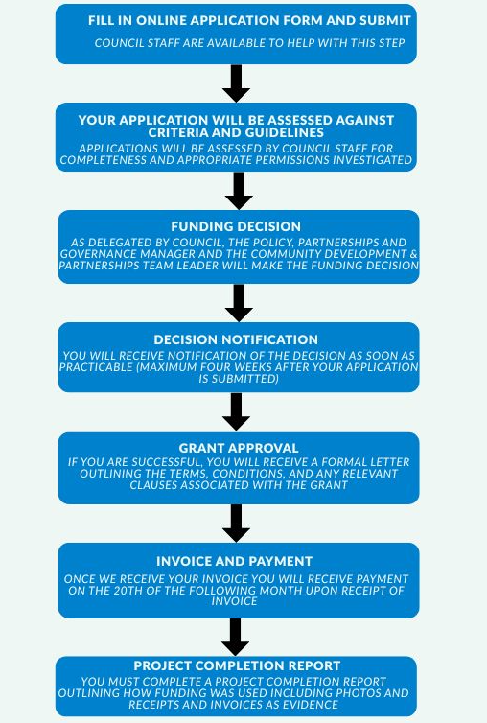

Schedule 1 – Guidelines and additional information

How to apply?
All application forms are available through Council’s online grant application system mpdc.nz/grants.

What are the requirements that have to be met by successful applicants?
Successful applicants may be required to complete a grant agreement prior to payment of the grant but in most instances, all requirements will be listed in the approval letter.
Successful applicants must adhere to the completion reporting requirements.
Recipients who fail to submit a completion report along with supporting receipts and invoices, or who have not utilised the grant funds in accordance with the conditions set out in the approval letter, will be deemed ineligible for further Council funding until:
- All outstanding documentation has been submitted and reviewed;
- Any use of funds not approved in the grant letter have been identified and resolved to the satisfaction of Council;
- Compliance with all grant conditions have been met/or grant monies returned.
Completion reports are due within one month of the finish date of the initiative.
Successful applicants must acknowledge Matamata-Piako District Council - Pride of Place project in all marketing materials, where other sponsors are being noted and where it is practical.

How will I know if funding has been approved?
Applicants will be notified of the decision as soon as practicable (maximum of four weeks after the application has been submitted).

Upon receipt of invoice, payment will be made on the 20th of the following month.
Application Process:
How much is available? | Total fund pool available is $30,000 per annum for 3 years (2024-2027).
How much can be applied for? | The maximum grant amount is $2,000 per application.  As this fund is intended for small initiatives most applications are expected to be less than the maximum amount.  If applicants are looking for higher levels of funding, they will be directed to other funding schemes.

Who can apply? | Groups and individuals can submit requests for funding.  Please contact Council’s Community Development and Partnerships team in the first instance to talk through ideas and get full eligibility requirements.  Call Council on 07 884 0060 and ask for the Community Development and Partnerships team or email prideofplace@mpdc.govt.nz
When to apply? | Applications are open throughout the year until the fund is fully allocated.  Applications are required at least two months before the proposed initiative is due to commence.
Utilising Funds | Funds must be utilised within 6 months after the approval letter has been sent and prior to the delivery of the initiative.
Timeframe | The initiative for which the grant is allocated must take place within 6 months of approval.
Ready to apply? | Reach out to Council’s Community Development and Partnerships team or click below:  https://www.mpdc.govt.nz/grants-and-funding

